The Shh Receptor Boc Promotes Progression of Early Medulloblastoma to Advanced Tumors

Highlights
- •Boc is upregulated in human and mouse medulloblastoma (MB) and induces proliferation
- •Boc inactivation reduces proliferation and progression of early MB to advanced tumors
- •Boc, through Shh signaling, promotes DNA damage, an effect mediated by CyclinD1
- •Boc-induced DNA damage causes LOH of its coreceptor Ptch1, leading to MB progression

Summary
During cerebellar development, Sonic hedgehog (Shh) signaling drives the proliferation of granule cell precursors (GCPs). Aberrant activation of Shh signaling causes overproliferation of GCPs, leading to medulloblastoma. Although the Shh-binding protein Boc associates with the Shh receptor Ptch1 to mediate Shh signaling, whether Boc plays a role in medulloblastoma is unknown. Here, we show that BOC is upregulated in medulloblastomas and induces GCP proliferation. Conversely, Boc inactivation reduces proliferation and progression of early medulloblastomas to advanced tumors. Mechanistically, we find that Boc, through elevated Shh signaling, promotes high levels of DNA damage, an effect mediated by CyclinD1. High DNA damage in the presence of Boc increases the incidence ofPtch1 loss of heterozygosity, an important event in the progression from early to advanced medulloblastoma. Together, our results indicate that DNA damage promoted by Boc leads to the demise of its own coreceptor, Ptch1, and consequently medulloblastoma progression.

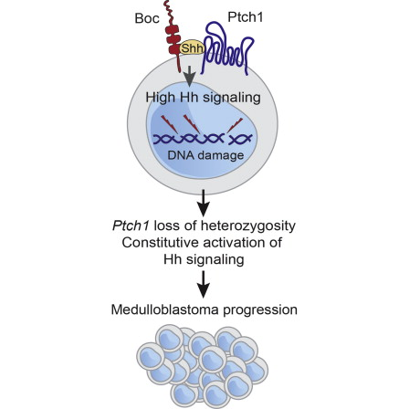

Researchers at the IRCM show that a protein called Sonic Hedgehog causes DNA damage

Scientists at the IRCM discovered a mechanism that promotes the progression of medulloblastoma, the most common brain tumour found in children. The team, led by Frédéric Charron, PhD, found that a protein known as Sonic Hedgehog induces DNA damage, which causes the cancer to develop. This important breakthrough will be published in the October 13 issue of the prestigious scientific journal Developmental Cell. The editors also selected the article to be featured on the journal’s cover.

Sonic Hedgehog belongs to a family of proteins that gives cells the information needed for the embryo to develop properly. It also plays a significant role in tumorigenesis, the process that transforms normal cells into cancer cells.

“Our team studied a protein called Boc, which is a receptor located on the cell surface that detects Sonic Hedgehog,” explains Lukas Tamayo-Orrego, PhD student in Dr. Charron’s laboratory and co-first author of the study. “We had previously shown that Boc is important for the development of the cerebellum, the part of the brain where medulloblastoma arises, so we decided to further investigate its role.”

“With this study, we found that the presence of Boc is required for Sonic Hedgehog to induce DNA damage,” adds Dr. Charron, Director of the Molecular Biology of Neural Development research unit at the IRCM. “In fact, Boc causes DNA mutations in tumour cells, which promotes the progression of precancerous lesions into advanced medulloblastoma.”

“Our study shows that when Boc is inactivated, the number of tumours is reduced by 66 per cent,” says Frederic Mille, PhD, co-first author of the article and former postdoctoral fellow in Dr. Charron’s research unit. “The inactivation of Boc therefore reduces the development of early medulloblastoma into advanced tumours.”

Medulloblastoma ranks among the leading causes of cancer-related mortality in children. Current treatments include surgery, as well as radiation therapy and chemotherapy. Although the majority of children survive the treatment, radiation therapy damages normal brain cells in infants and toddlers and causes long-term harm.

“As a result, many children who undergo these treatments suffer serious side effects including cognitive impairment and disorders,” states Dr. Charron. “Our results indicate that Boc could potentially be targeted to develop a new therapeutic approach that would stop the growth and progression of medulloblastoma and could reduce the adverse side effects of current treatments.”

About the research project
This research project was supported by grants from the Canadian Institutes of Health Research, the Canadian Cancer Society and the Cancer Research Society. Other authors from the IRCM include Martin Lévesque (co-first author), Julie Cardin, Nicolas Bouchard, and Luisa Izzi. The project was also conducted in collaboration with the laboratories of Stefan Pfister in Heidelberg, Germany, and Michael Taylor in Toronto.

